**IT Request**: 101476

**Title:** Fire SCON Pivotal order development

**Requestor:** Helen Buchan

**Request:**

Add new ‘Fire’ option to the service contract type in order capture view (Pivotal 5.9)

**Issues/opportunities:**

The business has expanded into the Fire safety market and are actively promoting fire safety service contracts to prospective customers. Members of the compliance team who are responsible for loading service contract orders into Pivotal 5.9 are unable to load fire safety contracts, as the order capture view for service contacts does not contain a “Fire” dropdown option in the “Contract Type” field.

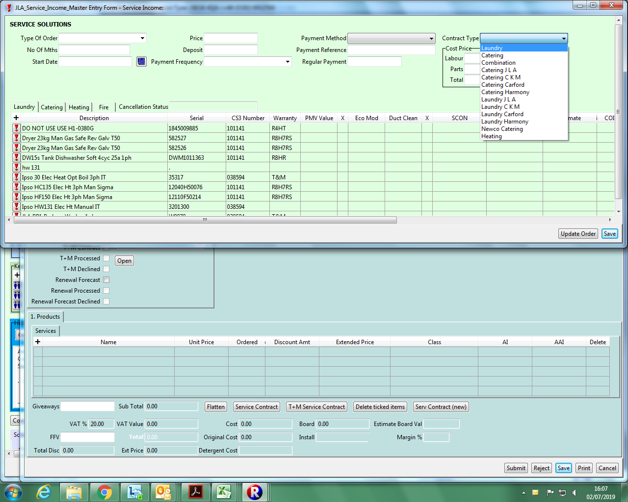

**Proposed changes**

1. Add ‘Fire’ as a contract type option in the dropdown field